**ADIS – Auto-Download and Installation Store**

**22-FYP-302**

**SESSION 2018-2022**

**BACHELOR OF SCIENCE**

**IN**

**Information Technology**

**SUBMITTED By**

**Abdul Sami 18-NTU-1194**

**M Wasi Anwar 18-NTU-1228**

**Suleman Tariq 18-NTU-1233**

**SUPERVISED BY CO SUPERVISED BY**

**Ma’am Sara Masood Dr. Mudassir Ahmad**

**DEPARTMENT OF COMPUTER SCIENCE**

**NATIONAL TEXTILE UNIVERSITY, P.O-37610 FAISALABAD**

# Revision History

|  |  |  |  |
| --- | --- | --- | --- |
| Name | Date | Steps | Version |
| Sami, Wasi,  Suleman | Feb 2021 | Start | 1.0 |
| Sami, Wasi,  Suleman | April 2021 | Improvement | 1.1 |
| Sami, Wasi,  Suleman |  | Basic Document  Standard | 1.2 |
| Sami, Wasi,  Suleman | May 2021 | Test cases | 1.3 |
| Sami, Wasi,  Suleman | July 2021 | UML Diagrams | 1.4 |
| Sami, Wasi,  Suleman |  | Revision of entire Document | 1.5 |
| Sami, Wasi,  Suleman | August 2021 | Improvement | 1.6 |

# Declaration

*We hereby declare that this project report entitled “Auto-Download and installation Store” is written by us and is our effort and that no part has been copied and taken from any other source.*

*Submitted by: Signature with Date*

Abdul Sami (18-NTU-1194) ____________________________________

M Wasi Anwar (18-NTU-1228) ____________________________________

Suleman Tariq (18-NTU-1233) ____________________________________

Ma’am Sara Masood ____________________________________

*Supervisor*

*Department of Computer Science*

Dr. Mudassir Ahmad ___________________________________

*Co-Supervisor*

*Department of Computer Science*

# Acknowledgment

Thanks to Almighty Allah for bestowing wisdom and courage on us to complete this project.

We would like to express our deepest gratitude to the individuals who supported us throughout the project.

First, we would like to Special thank our supervisor **Ma’am Sara Masood** for her patience, guidance, encouragement, insightful comments, and practical advice in making this project. We are thankful to her for her precious time spent guiding us and answering our queries. Without her help, this project completion would not have been possible. Thank our Co-Supervisor **Dr Mudassir Ahmad** for believing in us and encouraging us. We also wish to thank our Institute National Textile University for providing us with the facilities to complete this project. Thanks to our faculty members and HOD for their help and support.

We also thank our parents for their unceasing encouragement, support, and attention.

# Table of content

Revision History 2

Declaration 3

Acknowledgment 4

List of Tables 5

List of Tables 8

List of Figures 9

1. Introduction 11

**1.1 Introduction 12**

**1.2 Scope 12**

**1.3 Purpose of the Project 13**

**1.4 Project Planning: 13**

**1.5 Risk Management 14**

**1.6 Project Overview 15**

2. Literature Review 16

**2.1 Related work 17**

**2.2 ADIS us other App stores: 21**

**2.3 Reason for Development of ADIS: 21**

**2.4 Inspiration: 21**

3. Methodology 22

**3.1 Project Goals 23**

**3.2 Objectives of the project 23**

**3.3 Problems / Focus. 23**

**3.4 Existing Methodologies: [3][4] 24**

**3.5 Adaptive Methodology. 24**

1.1.1 Prototype [5] 24

1.1.2 Incremental Model 27

**3.6 Why we choose this Model? [6] 27**

4. System Requirements 28

**4.1 Functional Requirements [7][8] 29**

**4.2 Requirements Table 29**

**4.3 Non-Functional Requirements [9] 30**

4.3.1 Usability: 30

4.3.2 Availability: 30

4.3.3 Reliability: 30

4.3.4 Supportability: 30

4.3.5 Recoverability: 30

4.3.6 Safety: 30

4.3.7 Performance: 31

**4.4 Functional Requirements Diagram (Context) 31**

**4.5 Use Case Diagram [10][11] 32**

**4.6 ERD Diagram of System: [12][13] 35**

5. Architecture Design 36

**5.1 Architecture 37**

**5.2 Sequence Diagram [14] 37**

5.2.1 Overall system 37

**5.3 Activity Diagram 38**

**5.4 Class Diagram: 39**

6. Test 40

**6.1 Test Case 41**

**6.2 Blackbox Testing [15] 41**

7. User Manual 45

8. References 50

LIST OF TABLES

Revision History 2

**Requirements Table** 28

Test Case for Login 42

**Test Case for Registration data** 43

Test Case for Add Data Information 44

Test Case for Download and installation 45

Test Case for Sign out 45

# List of Figures

Figure 1: UI where you select the software 15

Figure 2: Installer Setup 16

Figure 3: Installer Downloaing Dropbox 16

Figure 4: Start Panel To Access Microsoft 17

Figure 5: UI of Microsoft Store 18

Figure 6: UI of Adobe Reader Installation Screen 18

Figure 7:Prototype Method 23

Figure 8:Incremental Model 25

Figure 9: Funcational Requirements Diagram 15

Figure 10: User Use Case 30

Figure 11: Admin Use Case 31

Figure 12: System Use Case 32

Figure 13: ERD Diagram of System 33

Figure 14: Sequence Diagram of Over All System 35

Figure 15: Activity Diagram of over All System 36

Figure 16: Class Diagram 37

Figure 17: Sign In 44

Figure 18: User Registration 44

Figure 19: Dashboard 45

Figure 20: Add Data 46

Figure 21: User Dashboard 47

Abstract

ADIS is a web-based application store portal for a textile company **INOX Fashion**. This system is an application store that will autonomously download and install applications to the user system from the server.

Before this system in the company, a person from the IT department manually downloads and installs the applications on the users' computer. The packages of applications were downloaded from different authentic and unauthentic resource, which also increases the risk of malware attacks.

With our new system, the employee of the company can be login and access the company application store from anywhere. The user can get an application ready just by selecting the required application. The application will be automatically downloaded and installed on the user system.

**(CHAPTER No. 1)**

# **Introduction**

## **Introduction**

The ADIS means Auto-Download and Installation System. The name of this system defines the features itself. The system was specifically designed and developed for the textile industry, but it can be used as public software after an advanced version of it. The functionality of ADIS is it automatically downloads and installed the requested software’s into a system from the source system that will be the central server of the industry

This system’s working depends on the power shell and commands prompt that will execute the action commands at the background of ADIS to achieve its objectives that were stored in the code. With the help of these then, ADIS fetches the requested software from the server and downloads it into the destination system that is auto-downloading and MSI that is an installer that is used to auto-complete the entire basic configuration needed in the installation of required software.

## **Scope**

Users can get the required applications from anywhere by accessing the company application web store. Any application can be uploaded and programmed to launch on this system. Any application can be downloaded and installed by selecting the application from the web portal.

This system can be used by other organizations or companies by just uploading the application packages to the store.

## **Purpose of the Project**

The basic purpose of developing this system is to provide a simple and easy platform for users from where they can get their required software’s just by a click.

For this, a web-based portal has been proposed.

* In which a user login and click on the software.
* The MSI activates
* It auto-downloads the package into the user’s computer
* After download the installation begins
* And the package is ready to use

## **Project Planning:**

|  |  |  |  |  |  |  |  |  |  |
| --- | --- | --- | --- | --- | --- | --- | --- | --- | --- |
| **Task** | **Dec** | **Jan** | **Feb** | **Mar** | **April** | **May** | **June** | **July** | **Aug** |
| Topic Selection |  |  |  |  |  |  |  |  |  |
| Finalize  Topic |  |  |  |  |  |  |  |  |  |
| Gather Requirements |  |  |  |  |  |  |  |  |  |
| Analyze Requirements |  |  |  |  |  |  |  |  |  |
| SRS Document |  |  |  |  |  |  |  |  |  |
|  |  |  |  |  |  |  |  |  |  |
| Write Document |  |  |  |  |  |  |  |  |  |
| Modify |  |  |  |  |  |  |  |  |  |
| Submit |  |  |  |  |  |  |  |  |  |

TABLE 1 PROJECT PLANNING

## **Risk Management**

Risk management is an important factor during the whole development of the project. It is very important to identify them and minimize them to make an effective product. If we handle and analyses risk effectively so there is a chance to achieve the desired goal. There is following risk involved in our project.

* The auto installation of software in the system of user is difficult to develop. Its takes a lot of research case study to find the right solution.
* It is difficult to handle the testing of projects on large scale.

## **Project Overview**

Providing the best web-based application store for the textile industry which helps to downloads and installs applications with all configurations autonomously. Our goal is to secure their computer systems and to ease the work of the user by providing a system that can be accessed from anywhere.

**(CHAPTER No.2)**

# **Literature Review**



## **Related work**

## The Microsoft store and Ninite are the systems that provide auto download and install feature, but these are for public used. But these stores do not fulfill the requirements of our client, so we have developed ADIS.

## Our client specifically wants his own private application store for the company on which all the package they need available and they auto download and install in the user’s system.

For this project we have gone through relevant literature for different working modules of our project which include books, manuals and research papers which are as follows:

**Ninite: [1]**

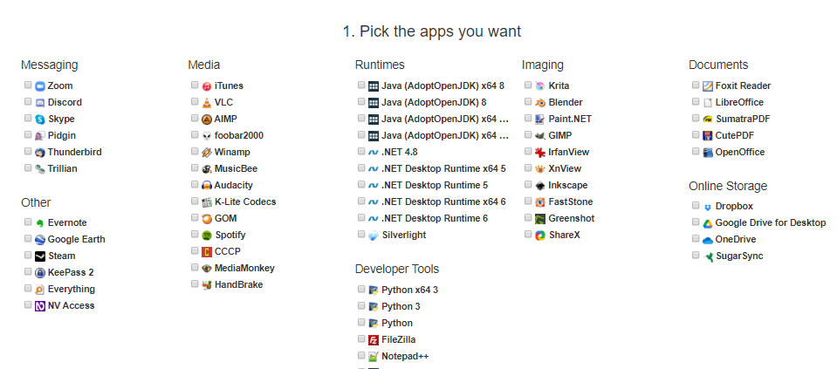Ninite is public use website that has general software’s required by public. It provides the feature of auto download and install but every time it uses installers for every software.

**Step 1:** On the webpage of Ninite, it provides multiple software’s that can be selected by the checkbox beside the software’s name.

Figure 1: UI where you select the software

### **Step 2:** Down to the selecting phase, it provides a button ‘Get Your Ninite” which starts downloading the installer of the selected software.

### 

### 

Figure 2: Installer startup

### 

### **Step 3:** In the last step the installer is installed and executed to install all the selected software’s. The installer automatically installs and configurate the package on default setting.

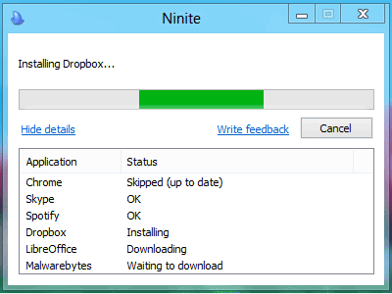

Figure 3: Installer downloading dropbox

## **Microsoft Store: [2]**

Microsoft store is a built-in application in windows 10 and 11 provided by Microsoft in their operating system. This store also downloads the software’s and other applications just by a click, but it is a public application store.

**Step 1:** To open the Microsoft Store, first click on the start button at the left bottom side of the screen when a panel is opened click on the Microsoft Store icon box. The store will be opened.

Figure 4: Start Panel to access Microsoft store

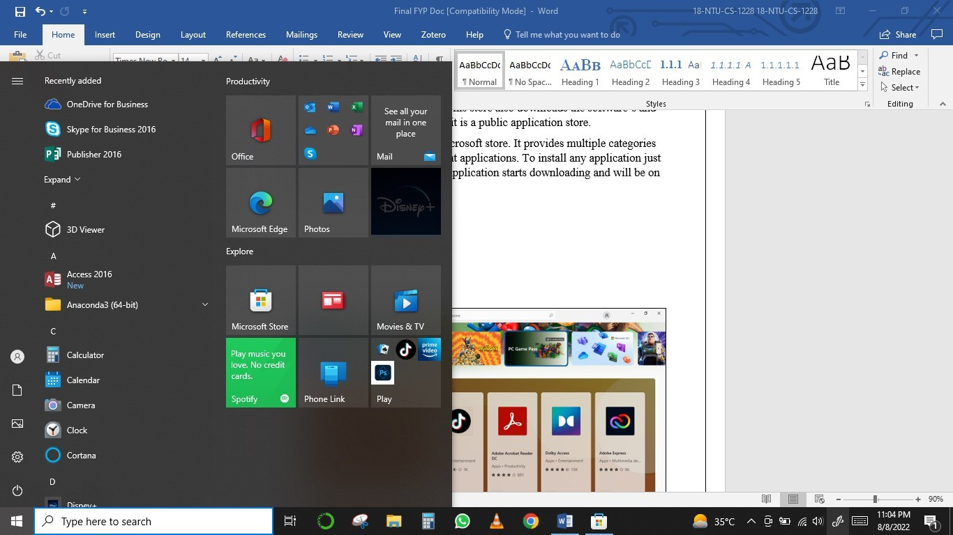

## **Step 2:** This is the main screen of Microsoft application store providing different categories of applications, games and movies. It has a search box to search a app in the store. To install an app just click on the app and click on install button the app will start downloading.

## 

Figure 5: UI OF Microsoft store

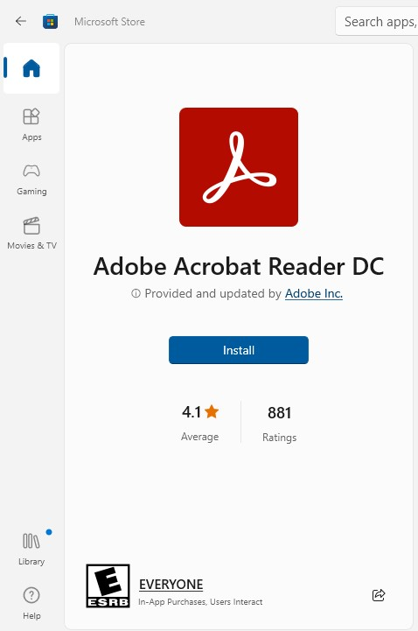

Figure 6: UI of Adobe reader installation screen

## **ADIS us other App stores:**

The first and important feature of ADIS is it’s not a public app store it is specified app store for a specific private use. Other app stores are made for public use and not have features required for a specified demand. The ADIS is faster then other and I doesn’t have any competitor app store which work exactly like ADIS.

## **Reason for Development of ADIS:**

## The reason to this development is first to assist textile people and to make them independent so they can download and install their software’s without any support/help and third to provide them a cheaper, reliable, efficient and easy to use product, so it can be easily accessible to them.

## While other systems are not accessible and reliable to users, but this system shall accommodate these things. The proposed solution uses windows System.

## **Inspiration:**

## In the textile industry users are downloading and installing their software’s manually from the random websites, and the packaged they download could be pirated. Also, in the installation process most of the people stuck due to complex and lengthy configuration of some software’s. Sometime their system faces malware attacks and slow down their work, so this system will solve their entire problem.

**(CHAPTER No. 3)**

# **Methodology**



## **Project Goals**

The major goal of this project is to make installation of applications easy for the users with securing the resources of the company.

## **Objectives of the project**

* The main objective of this project is to provide an easy solution to people those are not fully aware to get and install software’s by the right mean.
* They don’t need to find the crack version and worry about the installation process.
* Any software can be installed automatically according to their need form ADIS, and it will safe user time and secure his system from malwares.
* Due to the autonomous feature of the ADIS the user can rid from errors and time taking steps of configuration.

## **Problems / Focus.**

This system is a solution to a very common problem of the workers of the industry specifically in textile industry. The workers of the textile industry are not enough computers educated that they could download and install the required software’s according to their work and daily tasks or eventually if they can do it there is high risk of downloading of pirated and marvelous software that can cause damage or theft to the data of the system.

Even if they have downloaded software, they face the second problem in the installation of that software. They really do not know the configurations and steps they it takes to complete a software’s installation. Difference software’s have different way of configuration, sometimes it’s easy by few steps to complete the installation and sometimes it's too difficult and lengthy with a lot of steps.

For this problems’ solution there should be a system that be running on the server and any user can access the system from a portal by logging information and can download and install required software’s by a click. Just by a click on the required software, it auto downloads into the user’s system from the server and autonomously complete the installation of the software by default options and features, so it can be easy for a person to get his required software’s without wasting time on downloading the software from free websites and watching videos on the steps of installation.

## **Existing Methodologies: [3][4]**

System design is an important and essential part among the phases of System’s development Life Cycle (S.D.L.C). Because it specifies the information about its input, output, GUI, Coding, responsiveness, reliability and modularity. For a designer there are many strategies, techniques and methodologies to design system. The common design methods are:

* Water-Fall Model
* Water-Fall Iterative Model
* Spiral Model
* Prototype Model
* Incremental Model
* Agile
* Scrum

## **Adaptive Methodology.**

We are using the prototype model along with incremental model as we are testing, designing, and coding the device one module and feature at a time and improving on it afterwards

### **Prototype [5]**

In Prototype model instead of developing the software/ device as whole the work is done to create a working prototype instead according to the requirements and then it is improved upon as new modules or features are built on it. Prototype methodology includes the following:

* Requirement Elicitation.
* Requirement analysis
* Design
* Prototyping
* Review and Updating
* Customer Evaluation
* Development
* Testing
* Maintenance

Figure 7 Prototype Method

**Prototype Method Flow**

1. In Requirement Elicitation which is first step of this model. In this step we gather requirements according to users need.
2. In Requirement analysis, which is second step, we do analysis of requirements. After doing analysis we separate out such requirements which are implementable.
3. In third step which is Design Plan we plan to design the system and follow this plan in design phase of S.D.L.C.
4. In fourth step which is Prototype we do prepare a prototype of system.
5. Afterwards Review and Further updating takes places according to user needs
6. After detail design preparation we do enter in coding and testing step which is fifth step. In this step first, we code our system then we do test it to check out for errors.
7. If system codes pass-out this step, then we enter in Implementation / deployment which are second last step. Here we deploy our developed system.
8. After successful deployment we must maintain the system properly which is last step, so it can perform its working accurately.

Every step in the prototype model is necessary due to testing and ambiguous requirements same sequence.

It makes it easy to create a working model as a result and it becomes easy to resolve the issues and it is more reliable.

### **Incremental Model**

In incremental model the requirements are broken down into smaller modules and worked upon one by one, after one smaller standalone module is finished the next module is worked upon on.

Figure 8 Incremental Model

## **Why we choose this Model? [6]**

Due to following reasons, we choose this model:

1. Our requirements are clearly defined because they do not have any ambiguity in it.
2. Error isolation and resolution is easy.
3. We can find functional and design related flaws as soon as possible.
4. New technology is being used and is being learned by the development team.
5. If we must change in project features in future, then we can do this.
6. Because we can plan concurrent development.
7. Our project scale is not small, and it is a large project for development.
8. We must spend less time on documentation and more time on designing and development.

**(CHAPTER No. 4)**

# **System Requirements**



## **Functional Requirements [7][8]**

Major Functional Requirements of our system are described below:

### **Sign in/ Sign out**

The user can sign in and sign out from store by using his personal username and password.

### **User Record**

The user record can be saved in the database by using registration Form.

### **Auto Download**

The application will be downloaded automatically from web portal to user’s system.

### **Auto Installation**

The installation of the selected application can be automatically completed after downloading.

## **Requirements Table**

|  |  |
| --- | --- |
| **Requirement No.** | **Details** |
| Functional Requirement 1 | **Sign in/ Sign out** |
| Functional Requirement 2 | **User Record** |
| Functional Requirement 3 | **Auto Download** |
| Functional Requirement 4 | **Auto Installation** |

Table 2 Functional Requirements

## **Non-Functional Requirements [9]**

Following are the Non-functional requirements of our device which are illustrated as:

### **Usability:**

We analyze our audience and then design the system. So, our system must be easy to use. Essay to understand. Our system must be efficient for the user. In target audience system design is very important. If a user cannot understand the system and irritate from it. So, usability is the main non-functional requirement. Good usability is the user must learn all systems from one drive.

### **Availability:**

Availability is an important feature of an application. system must be available 24/7.

### **Reliability:**

In a mobile application, there is more chance of reliability issues (crashing app, etc.). Our system must be reliable as any failure can occur identify it easily.

### **Supportability:**

This system is easily supportable to developers to add additional features in it in future. All supportive documents and diagrams shall be provided with it in case for understanding of developers and stakeholders.

### **Recoverability:**

A good system adopts modification (Change) easily. Our system will satisfy maximum limitation and modification. We develop our system in a phase development.

### **Safety:**

All the applications available on the store are paid to avoid malwares of pirated software’s.

### **Performance:**

A good performance of a system is that the system response same time in any situation. For a real-time, application, it is very necessary to respond in a short time. So, we are using the latest technology Node.js for backend development. Node has the following features as compared to PHP and Laravel framework.

* Build twice faster.
* 33% fewer line of code
* 40% fewer file
* Twice request /sec
* 35% faster response

From Node.js we minimize performance issue in our real time application.

## **Functional Requirements Diagram (Context)**

Figure 9 ConteXT dIAGRAM

## **Use Case Diagram [10][11]**

### **User Use Case Diagram**

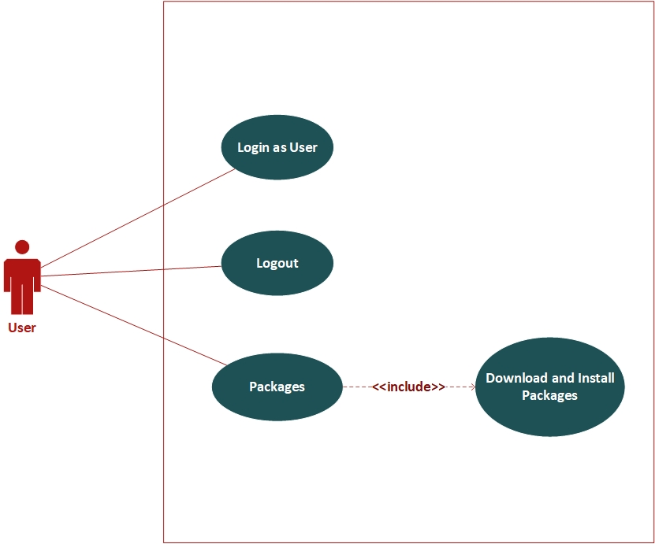

Figure 10 USER uSECASE DIAGRAM

### **Admin Use Case Diagram**

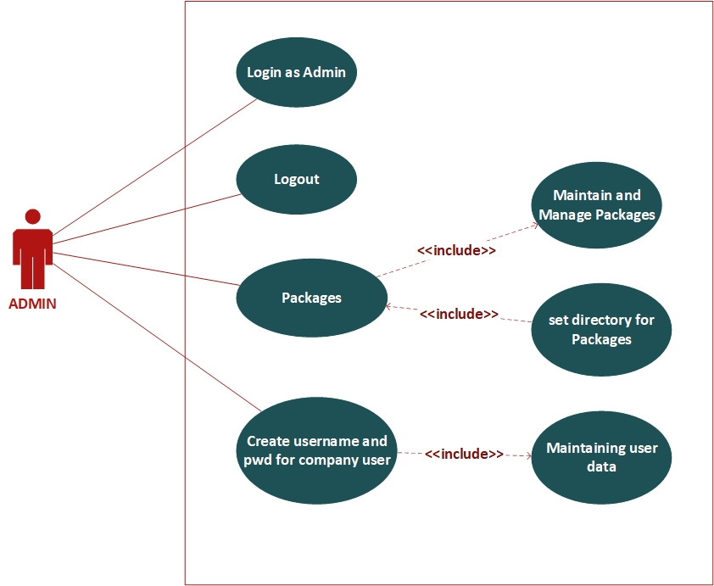

Figure 11 Admin USECASE DIAGRAM

### **System Use Case Diagram**

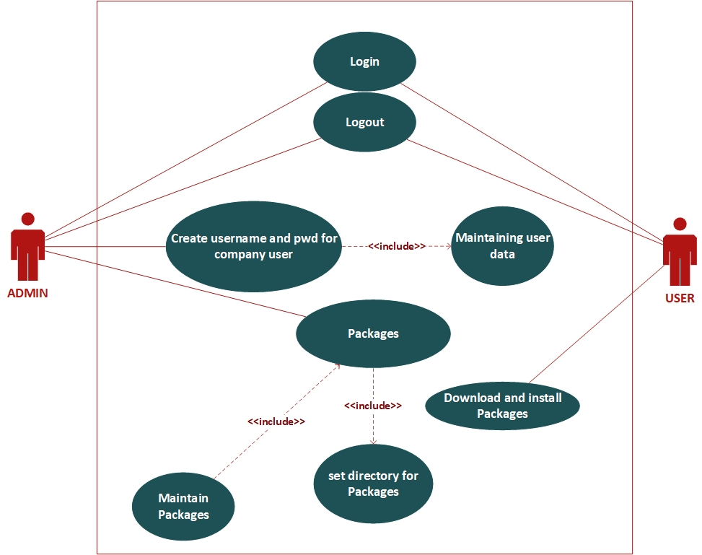

Figure 12 SYSTEM USECASE DIAGRAM

## **ERD Diagram of System: [12][13]**

Figure 13 erd diagram of system

**(CHAPTER No. 5)**

# **Architecture Design**

## **Architecture**

In our project, Architecture describe the project working pattern and its framework. It helps in using system so that user can easily use it. It also helps to understand the functionality of the system easily.

## Sequence Diagram [14]

### **Overall system**

Figure 14 Overall system sequence diagram

## **Activity Diagram**

Figure 15 activity diagram

## **Class Diagram:**

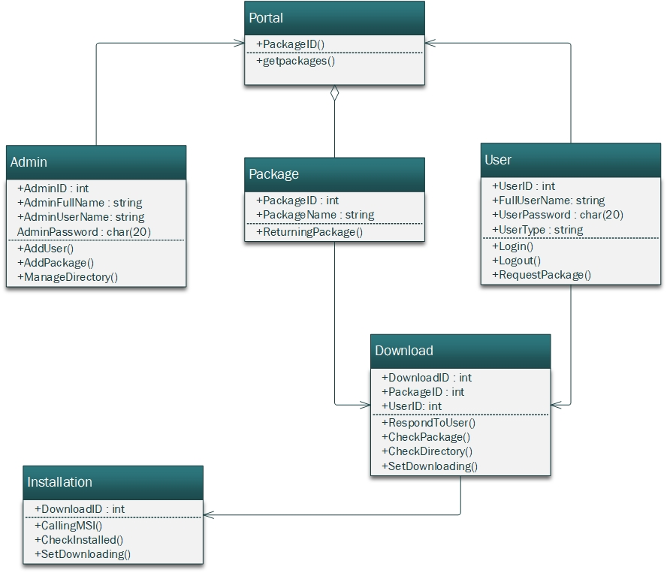

Figure 16 Class diagram

**(CHAPTER No. 6)**

# Test

## Test Case

Test cases are created to ensure that your system works properly. For various features, test cases are created, and the output determines if the system is working correctly under specific conditions.

## Blackbox Testing [15]

A type of testing in which the tester is unaware of the system's structure, design, or code. Different inputs are used to test the system, and the results of these inputs are matched with expected outputs.

Test Case for Login

|  |  |  |  |  |  |
| --- | --- | --- | --- | --- | --- |
| **Test Case** | **Test Scenario** | **Test Steps** | **Expected Result** | **Result** | **Pass/**  **Fail** |
| 1 | Enter invalid email/password | Enter email, password. | Email: shahid@gmail.com  Password=123456 | Invalid email/password | Pass |
| 2 | Enter invalid email/password | Enter email, password. | Email= waqas@gmail.com  Password=123456 | Invalid email/password | Pass |
| 3 | Enter valid email/password | Enter email, password. | Email=waqasahmad@ntu.edu.pk  Password=123456 | Valid email/password | Pass |

## Test Case for **Registration data**

|  |  |  |  |  |  |
| --- | --- | --- | --- | --- | --- |
| 5 | Enter Registration data | Enter  First Name, Last Name, E-mail, CNIC password, | First Name: Suleman  Last Name: Tariq  CNIC: 3310053931288  Email: SulemanT12@gmail.com  password=123456 | Registered  Successfully | Pass |
| 6 | Enter Registration data | Enter  First Name, Last Name, E-mail, CNIC password, | First Name: Wasi  Last Name: Anwar  CNIC: 3310182931288  Email: chishtiT12@gmail.com  password=1222456 | Registered  Successfully | Pass |
| 7 | Enter Registration data | Enter  First Name, Last Name, E-mail, CNIC password, | First Name: Sami  Last Name: Saeed  CNIC: 3310050001288  Email: SamiT12@gmail.com  password=100456 | Registered  Successfully | Pass |

Test Case for **Add data information**

|  |  |  |  |  |  |
| --- | --- | --- | --- | --- | --- |
| 8 | Enter  Add data information | Enter  Name, set title, Upload Icon, Upload file, | Name: Media Player  set title: VLC  Upload Icon: VLC_Icon  Upload file: File_Name | Add data Successfully | Pass |
| 9 | Enter  Add data information | Enter  Name, set title, Upload Icon, Upload file, | Name: office Management  set title: MS Office  Upload Icon: Office_Icon  Upload file: File_Name | Add data Successfully | Pass |
| 10 | Enter  Add data information | Enter  Name, set title, Upload Icon, Upload file, | Name: office Management  set title: MS Office  Upload Icon: Office_Icon  Upload file: File_Name | Add data Successfully | Pass |

Test Case for **Download and Installation**

|  |  |  |  |  |  |
| --- | --- | --- | --- | --- | --- |
| 11 | Download | Select 1st software | Download software Automatically | Download  Successfully | Pass |
| 12 | Installation | Selected 1st software | Installation of software Automatically | Installed Successfully | Pass |
| 13 | Download | Select 2nd software | Download software Automatically | Download  Successfully | Pass |
| 14 | Installation | Selected 2nd software | Installation of software Automatically | Installed Successfully | Pass |
| 15 | Download | Select 3rd software | Download software Automatically | Download  Successfully | Pass |
| 16 | Installation | Selected 3rd software | Installation of software Automatically | Installed Successfully | Pass |

Test Case for **Sign out**

|  |  |  |  |  |  |
| --- | --- | --- | --- | --- | --- |
| 17 | Sign Out | Select Sign out | Sign out | Sign Out Successfully | Pass |

**(CHAPTER No. 7)**

# User Manual

## **Sign IN**

Sign In to access the application store.

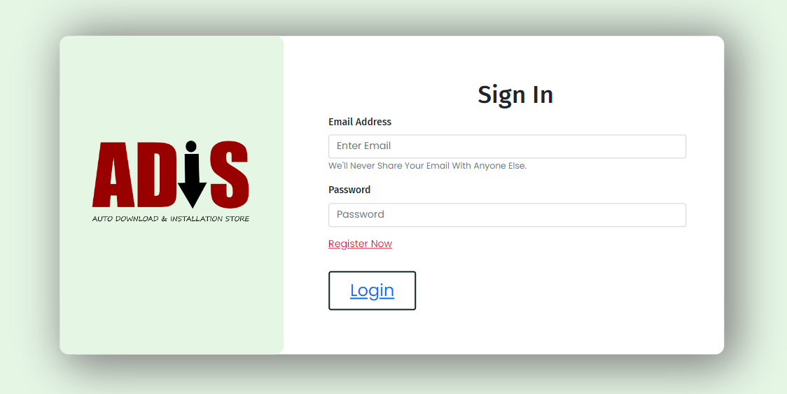

## 

Figure 17: UI Of Sign IN

## **User Registration**

To register the user, the user information is entered on the registration form.

Figure 18: User Registration

## **Dashboard**

This is the dashboard of the application store from where user can access the applications and its features.

Figure 19: Dashboard

## **Add Data**

In the form of add data the admin can upload a new application package on the store.

Figure 20: UI of Add Data

## **User Dashboard**

This is the dashboard of the application store from where user can access the applications and its features

Figure 21: User Dashboard

# References

[1] “Ninite | Install or Update Multiple Apps at Once.”

[**https://ninite.com/**](https://ninite.com/) (accessed November 23, 2021).

[2] “Microsoft Store”

[**https://apps.microsoft.com/store/apps**](https://apps.microsoft.com/store/apps) (accessed November 25, 2021).

**[3] “TatvaSoft – Software Development Methodologies”**

**https://www.tatvasoft.com/blog/top-12-software-development-methodologies-and-its-advantages-disadvantages/** (accessed January 5, 2022).

**[4] “Team Work | Which project management methodologies should you use ?”**

[**https://www.teamwork.com/project-management-guide/project-management-methodologies/**](https://www.teamwork.com/project-management-guide/project-management-methodologies/)(accessed January 5, 2022).

**[5] “Guru99 | Prototyping Model in Software Engineering”**

[**https://www.guru99.com/software-engineering-prototyping-model.html**](https://www.guru99.com/software-engineering-prototyping-model.html)

(accessed January 10, 2022).

[6] “Guru99 | **Incremental Model in SDLC: Use, Advantage & Disadvantage”**

[**https://www.guru99.com/what-is-incremental-model-in-sdlc-advantages-disadvantages.htm**](https://www.guru99.com/what-is-incremental-model-in-sdlc-advantages-disadvantages.htm)(accessed January 11, 2022).

**[7] “Guru99 | What is a Functional Requirement in Software Engineering? Specification, Types, Examples”**

[**https://www.guru99.com/functional-requirement-specification-example.html#:~:text=A%20Functional%20Requirement%20(FR)%20is,%2C%20its%20behavior%2C%20and%20outputs**](https://www.guru99.com/functional-requirement-specification-example.html#:~:text=A%20Functional%20Requirement%20(FR)%20is,%2C%20its%20behavior%2C%20and%20outputs)**.** (accessed March 27, 2022).

**[8] “GeekforGeek | Functional vs Non-Functional Requirements.”**

[**https://www.geeksforgeeks.org/functional-vs-non-functional-requirements/**](https://www.geeksforgeeks.org/functional-vs-non-functional-requirements/)

(accessed April 7, 2022).

**[9] “GeekforGeek | Functional vs Non-Functional Requirements.”**

[**https://www.geeksforgeeks.org/functional-vs-non-functional-requirements/**](https://www.geeksforgeeks.org/functional-vs-non-functional-requirements/)

(accessed April 7, 2022).

**[10] “Visual Paradigm - What is Use Case Diagram? ”**

[**https://www.visual-paradigm.com/guide/uml-unified-modeling-language/what-is-use-case-diagram/**](https://www.visual-paradigm.com/guide/uml-unified-modeling-language/what-is-use-case-diagram/)(accessed May 01, 2022).

**[11] “ Lucidchart - UML Use Case Diagram | Tutorial”**

[**https://www.lucidchart.com/pages/uml-use-case-diagram**](https://www.lucidchart.com/pages/uml-use-case-diagram)

(accessed May 01, 2022).

**[12] “Lucidchart – What is an Entity Relationship Diagram (ERD)?”**

[**https://www.lucidchart.com/pages/er-diagrams**](https://www.lucidchart.com/pages/er-diagrams)(accessed May 05, 2022).

**[13] “Lucidchart | Online ER Diagram Maker - Make ER Diagrams in Minutes?”**

[**https://www.lucidchart.com/pages/er-diagrams**](https://www.lucidchart.com/pages/er-diagrams)(accessed May 05, 2022).

**[14] “Lucidchart |What is sequence diagram?”**

[**https://www.lucidchart.com/pages/er-diagrams**](https://www.lucidchart.com/pages/er-diagrams)(accessed June 01, 2022).

[15] **“Guru99 | What is BLACK Box Testing? Techniques, Example Types**”

[**https://www.guru99.com/black-box-testing.html**](https://www.guru99.com/black-box-testing.html)(accessed June 3, 2022).